**Q2**

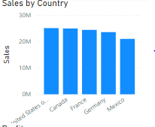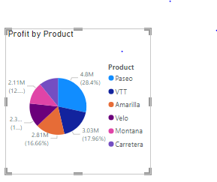

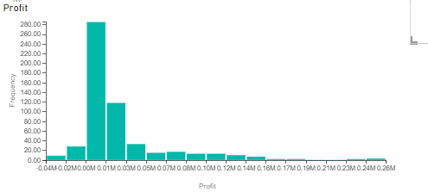

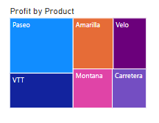

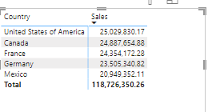

**A relationship between product, country, profits, and sales was analysed here. According to visuals** highest sales is in united states of America, lowest sale is in Mexico. paseo is the most sold item as indicated by pie chart and treemap. According to histogram the data is positively skewed. 0.00-0.001 is the most frequent profit range.

Lowest sale is in Mexico so the company should work to increase sales in that region, try to find the reason for low sale, may the customers are not satisfied with location of the store, the store may be in an area which is not accessible or not liked by people, due to rushy or community with bad impression. Try to do a deep analysis for a reason, you may conduct research about your store.

Carretera has the lowest sale, company may announce sale on that product, or use some advertisemewnt strategy to increase sale of that product.